

|  |
| --- |
|  |
| "Maximizing Airline Occupancy: A Data-Driven Approach to Revenue and Service Optimization" |
| Created by: Shahuraj Ambesinge |

The fundamental analysis of airline data provides insights into aircraft with more than 100 seats, analysing how the number of seats booked and total earnings have changed over time, as well as the average fare for each aircraft under different conditions. These data will be useful in developing strategies for increasing occupancy rates and optimising pricing for each aircraft type.

Table 1 shows aircrafts with more than 100 seats and the actual count of the seats.

|  |  |  |
| --- | --- | --- |
| Sr no. | aircraft_code | no_seats |
| 1 | 319 | 116 |
| 2 | 320 | 140 |
| 3 | 321 | 170 |
| 4 | 733 | 130 |
| 5 | 763 | 220 |
| 6 | 773 | 402 |

Table 1

To gain a deeper understanding of the trend in ticket bookings and the revenue generated from these bookings, a line chart visualization was used. The analysis of the chart revealed a gradual increase in the number of tickets booked from June 22nd to July 7th, followed by a relatively stable pattern from July 8th until August. There is a noticeable peak in ticket bookings, with the highest number of tickets booked on a single day. It is important to note that the revenue earned by the airline company from these bookings closely mirrors the trend in the number of tickets booked. Consequently, we observe a similar trend in total revenue throughout the analysed period.

These findings suggest that further exploration of the factors contributing to the peak in ticket bookings could be valuable for increasing overall revenue and optimizing operational strategies.

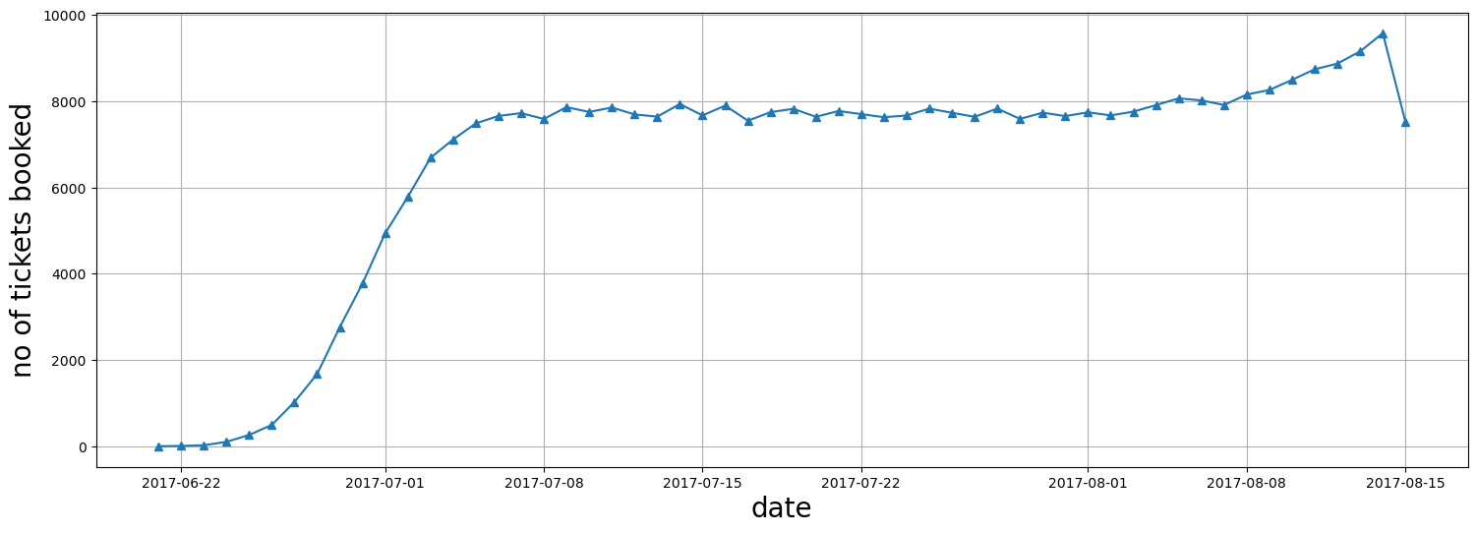

**Figure 1**

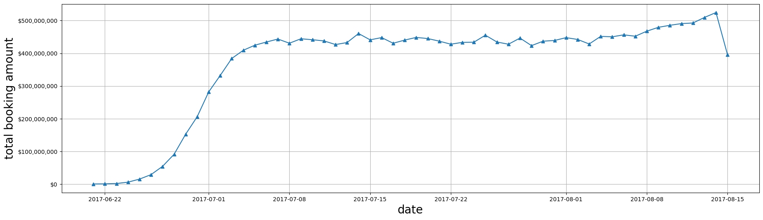

**Figure 2**

We generated a bar graph to compare the average costs associated with different fare conditions for each aircraft after completing the computations. Figure 3 displays data for three types of fares: business, economy, and comfort. When comparing different pricing conditions within each aircraft, the fares for business class are consistently higher than those for economy class.

This trend is evident across all aircraft types, regardless of fare conditions.

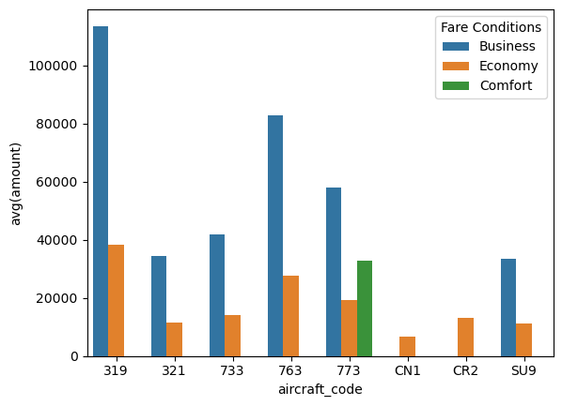

Figure 3

Analyzing Occupancy Rate

Airlines need to conduct a thorough analysis of their revenue streams to maximize profitability. Key metrics to consider include the overall annual income and the average revenue per ticket for each aircraft. By examining these factors, airlines can identify which aircraft types and routes are most profitable, allowing them to adjust their operations accordingly. This research can also highlight opportunities for pricing optimization and resource allocation to more lucrative routes. Figure 4 below illustrates the total revenue, total tickets sold, and average revenue per ticket for each aircraft

The aircraft with the highest revenue is the SU9. As shown in Figure 3, this aircraft has the lowest prices for both business class and economy class tickets. This pricing strategy likely contributed to its highest ticket sales, making it more popular compared to other aircraft. On the other hand, the aircraft with the least revenue is the CN1. A potential reason for this is that it only offers economy class tickets at very low prices, possibly due to its poor condition or lack of amenities. The 319 aircraft has the highest average revenue per ticket, which is attributed to having more business class seats.

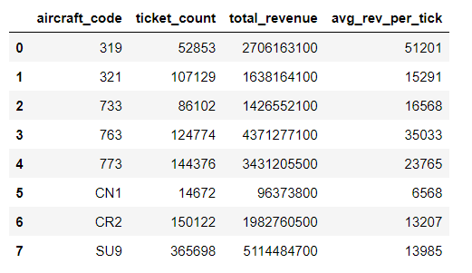

Figure 4

The average occupancy per aircraft is another critical metric to consider. Airlines can measure how effectively they fill their seats and identify opportunities to boost occupancy rates using this metric. A higher occupancy rate can help airlines increase revenue and profitability while reducing operational expenses associated with vacant seats. Factors influencing occupancy rates include pricing strategy, airline schedules, and customer satisfaction. Figure 5 below shows the average number of booked seats relative to the total number of seats for each aircraft. The occupancy rate is calculated by dividing the booked seats by the total number of seats. A higher occupancy rate indicates that more seats are booked, leaving fewer seats unbooked.

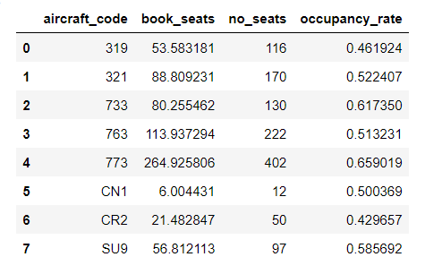

Figure 5

Airlines can assess how much their total yearly turnover could improve by providing all aircraft by a 10% higher occupancy rate to further examine the possible benefits of occupancy rates. This research can assist airlines in determining the financial impact of boosting occupancy rates and if it is a realistic strategy.

Airline may enhance occupancy rates and revenue and while delivering greater value and service to customers by optimizing pricing tactics and other operational considerations.

The below figure 6 shows the total revenue increased after increasing the occupancy rate by 10% and it gives the result that it will increase gradually so airlines should be more focused on the pricing strategy.

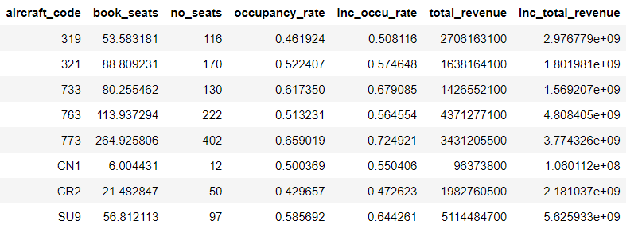

Figure 6

Conclusion

To summarize, analysing revenue data such as total revenue per year, average revenue per ticket, and average occupancy per aircraft is critical for airlines seeking to maximize profitability. By assessing these indicators, airlines can identify areas for improvement and adjust their pricing strategies and route plans accordingly. A higher occupancy rate is particularly important for enhancing profitability, as it enables airlines to maximize revenue while minimizing costs associated with vacant seats.

Additionally, airlines should review and adjust the pricing for each aircraft. Extremes in ticket prices, whether too low or too high, can deter potential passengers. Pricing should reflect the condition and amenities of the aircraft, ensuring it is neither excessively cheap nor prohibitively expensive.

Furthermore, boosting occupancy rates should not come at the expense of customer satisfaction or safety. Airlines must strike a balance between the need for profit and the importance of delivering high-quality service and upholding safety regulations. By adopting a data-driven approach to revenue analysis and optimization, airlines can achieve long-term success in a highly competitive industry.